Hong Kong Exchanges and Clearing Limited and The Stock Exchange of Hong Kong Limited take no responsibility for the contents of this announcement, make no representation as to its accuracy or completeness and expressly disclaim any liability whatsoever for any loss howsoever arising from or in reliance upon the whole or any part of the contents of this announcement.

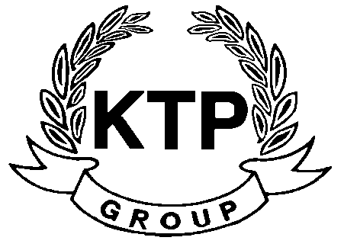
KTP HOLDINGS LIMITED
港台集團有限公司*
(Incorporated in Bermuda with limited liability)
(Stock code: 645)

UNUSUAL PRICE & TRADING VOLUME MOVEMENTS

This statement is made at the request of The Stock Exchange of Hong Kong Limited.

The board of directors (the “Board”) of KTP Holdings Limited (the “Company”) has noted today’s increase in the price and trading volume of the shares of the Company and wishes to state that the Board is not aware of any reasons for such movements save as the possible disposal of all or part of the Company’s shareholding by the controlling shareholder of the Company as disclosed in the Company’s announcements dated 5th August 2010 and 10th August 2010.

The Board also confirms that, save as aforesaid, there are no negotiations or agreements relating to intended acquisition or realizations which are discloseable under Rule 13.23 of the Rules Governing the Listing of Securities on The Stock Exchange of Hong Kong Limited (the “Listing Rules”), neither is the Board aware of any matter discloseable under the general obligation imposed by Rule 13.09 of the Listing Rules which is or may be of price sensitive nature.

Made by the order of the Board, the directors of which individually and jointly accept responsibility for the accuracy of this statement.

By Order of the Board
KTP Holdings Limited
Lee Chi Keung, Russell
Chairman

Hong Kong, 24th August 2010

As at the date of this announcement, the Board is comprised of 5 Directors, of which Mr. LEE Chi Keung, Russell (Chairman) and Ms. YU Mee See, Maria are executive Directors, Mr. NG Wai Hung, LEE Siu Leung and Mr. YUEN Sik Ming are independent non-executive Directors.

*For identification purpose only

